BREECH PRESENTATION
Breech is a longitudinal lie with variation in polarity. The fetal pelvis is the leading pole. Denominator is the sacrum. LSA is most common breech position where fetal sacrum occupies left anterior quadrant of maternal pelvis and bitrochanteric diameter occupies left oblique diameter of pelvis.
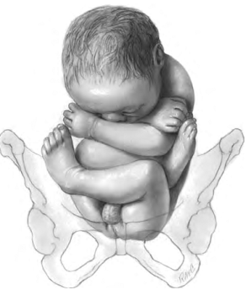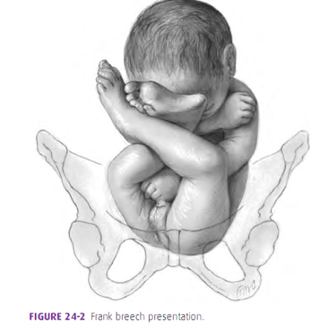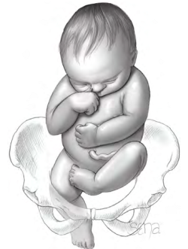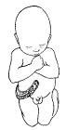
Complete Breech Frank Breech Footling Presentation Knee Presentation
Complete Breech: Flexion at hip and knee (10%)
Frank breech Fexion at hip And extension at knee(70%)
Footling Both hip and knee partially extended (25%)
Kneeling hip is extended and knees are flexed

Management of vaginal breech delivery

Spontaneous breech delivery: Assisted breech delivery: Breech extraction:
expulsion of the fetus delivery of breech is by assistance the entire breech is
occurs with no assistance from the umbilicus to the end is extracted by the
. body of the fetus obstetrician

BRUSH ASIDE
B-Bladder empty and Breech on perineum
R-Rotate thighs,flex knees of the mother, remove the lower limb of the baby
U-Umbilicus visible
S-Sacrum anterior
H-Hold on!
A-Avoid traction/stimulation/soft tissue injury
S-Scapulae visible
I-Initiate arm rotation to anterior
D-Deliver the head
E-Explain and document

ASSISTED BREECH DELIVERY
Principles of breech delivery
- Never push from above
- Never pull from below
- Always keep back anterior
Steps:
1.under aseptic precautions, empty bladder, dorsal position ,adequate analgesia
2. episiotomy is given to straighten the birth canal, facilitate intravaginal manipulation and for forceps delivery , to minimize compression of the aftercoming head.
3. patient is encouraged to bear down till umbilicus is born.
4. umbilical cord is to be mobilized to one side.
5. baby is wrapped with a sterile towel
DELIVERY OF ARMS:
When the axilla is visible and vertebral border of the scapula remains parallel, arms are delivered one after the other.
DELIVERY OF ARMS
- If inferior angle of scapula seen : NORMAL delivery
- Inferior angle of scapula visible and axilla not visible : LOVSET’s
- Inferior angle of scapula and axilla not visible: CLASSICAL METHOD

Lovset
- inferior angle of the scapula is seen
- Axilla is not seen

Principle: as the pelvic canal is curved ,the anterior shoulder lies above symphisis pubis and posterior shoulder below sacral promontory .When the fetal trunk is rotated keeping back anterior ,then posterior shoulder will come below symphisis pubis.
Manoeuvre PROCEDURE
- Hold the baby firmly but gently around the pelvis
- Rotate the body 180˚
- Keep the baby’s BACK ANTERIOR
- The posterior shoulder is now lying under the symphysis pubis
- Splint the humerus and draw it down over the chest with the elbow flexed to facilitate delivery
- Rotate the baby back through 180 degrees KEEPING THE BACK ANTERIOR
- The second arm can be delivered in the same way

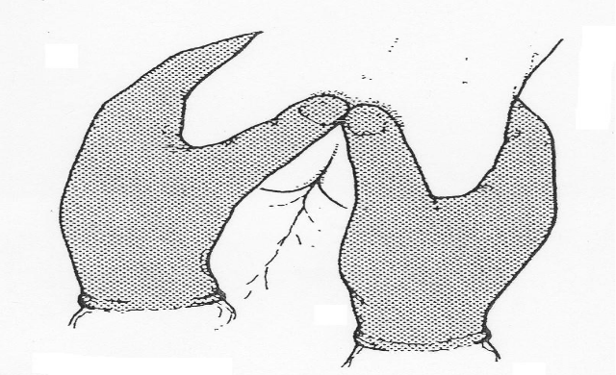
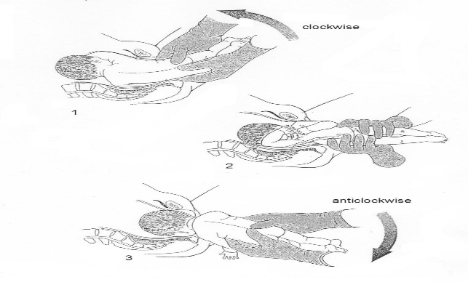
Nuchal Arm
In this position, the shoulder is extended and elbow flexed so that the forearm is trapped behind the occiput. This usually occurs due to inappropriate traction and rotational manoeuvres at an earlier stage in the delivery. To overcome this problem fetal trunk is rotated in the direction of fetal hand. The occiput thus rotates past the arm and, with further rotation, flexion of the shoulder should occur and allow delivery of the arm.
Identification :winging of scapula is seen on that side
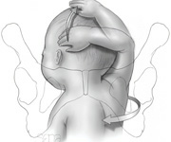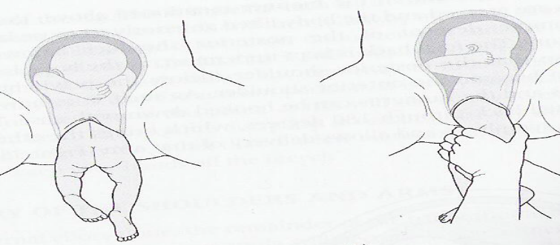
Classical method of delivering shoulders
This is a part of breech extraction
- For extended arms
- When inferior angle of the scapula is also not seen
- Under general anaesthesia,

- Procedure:
- Keep the back anterior
- give traction to make scapula visible
- rotate the baby by shortest distance to make one of the shoulders posterior.
- lift the baby up and introduce hand into pelvis
- Reach elbow ,flex it and bring it down.
- Adduct the arm and sweep it across fetal chest.
- Deliver anterior shoulder in similar manner.
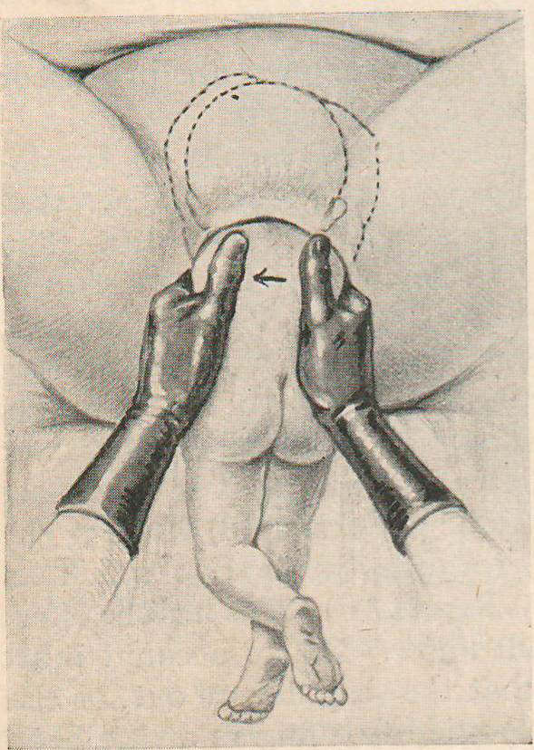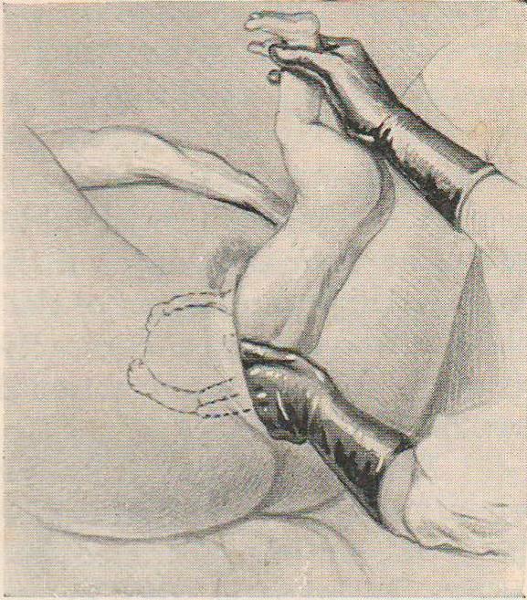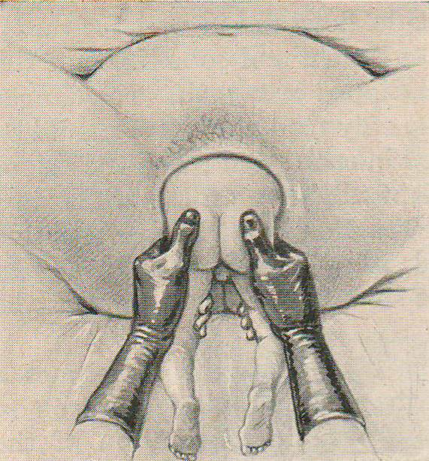
Delivery of after coming head
Burns-Marshall maneuver
- Done when nape of the neck is seen

- Assistant gives Suprapubic pressure(Kristellar manouvre)
- Lower the Body – nape of neck pivots and flexion is maintained

- Grasp the ankles with a finger in between and forming a wide arc of circle
- Swing the trunk in upward and forward direction towards the maternal abdomen forming a wide arc.
- Deliver face and brow supporting perineum

Piper forceps on the aftercoming head

- Grasp the feet and lift the body using towel (Savage technique)
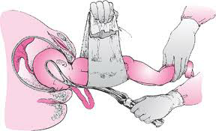
- Left blade followed by right – occipitomental diameter
- Traction directly on head – avoids damage to structures in the neck
An assistant should hold the baby just above the horizontal plane and forceps are applied below the body. It is important not to allow the fetal body to be raised much above the horizontal, as this risks hyperextension of and trauma to fetal cervical spine. As the head is delivering, and once the fetal chin and mouth are visible, the forceps and the body of the fetus are raised together to complete delivery.
Entrapped head after preterm breech delivery.
- Catheterise the bladder
- Perform McRoberts manoeuvre – this may release the head
- Assistant is asked to apply firm suprapubic pressure to encourage flexion of the head (Kristellar manouvre )
- Acute cervico-uterine relaxation is achieved by using terbutaline 250 microgram subcutaneously or nitroglycerine 1 x 400microgram puff sublingually to help in stretching or dilating the cervix
- Duhrssen cervical incisions. If the above measures fail, cervical incision at 2 &10 o clock may facilitate the delivery of fetal head but has risk of massive maternal haemorrhage. Care should be taken as these tears may extend into lower segment.
- Mento-anterior position: Delivery of entrapped head is more difficult in a mento-anterior position. Rotation and flexion of the fetal head may not be possible. Laparotomy and hysterotomy may be required.

Wigand – Martin Maneuver –
- When nape of the neck not seen
- Body of the baby on operator’s hand
- One finger in baby’s mouth and two on malar bones, other hand exerts suprapubic pressure
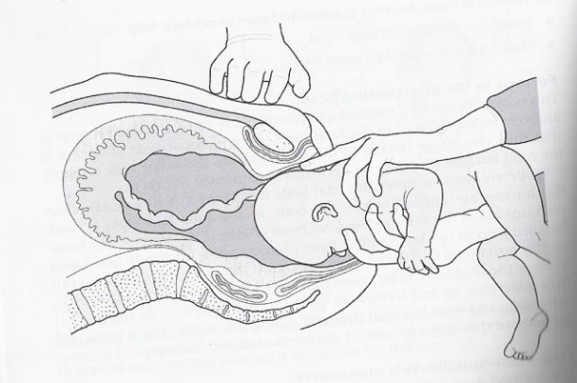
Mauriceau – Smellie – Veit Maneuver –
- Controlled delivery of the head is vital to avoid any sudden change in intracaranial pressure.
- Baby to be placed over the forearm supporting the baby’s chest with the palm of the hand.
- NB: Do NOT put finger in baby’s mouth – there is a risk of causing trauma and will not aid flexion of the head. First and second fingers of other hand to be placed on the baby’s cheek bones.
- first and third fingers of other hand to be placed over the baby’s shoulders to apply traction, whilst the middle finger presses on the occiput to aid flexion and descent.
- When the face distends the perineum, apply upward traction until the mouth and nose are free, the head can now be delivered slowly.

Other maneuvers in breech extraction
Pinard Maneuver –
- Frank breech vdecomposition
- Under anesthesia
- Exert pressure against popliteal fossa in backward and outward direction flexion of knee
- Grasp foot and deliver

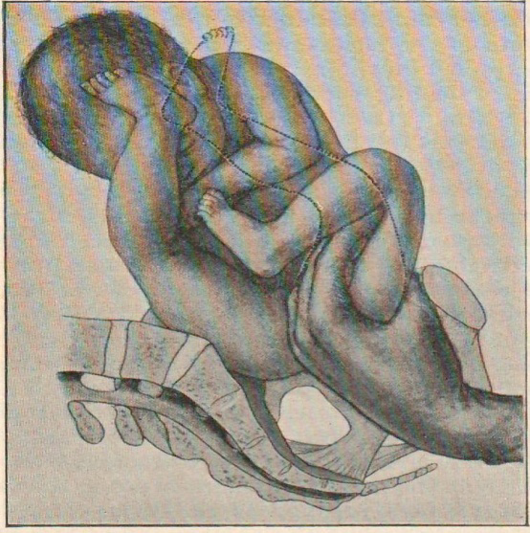

Classical method of delivering shoulders
- For extended arms
Has been explained before.

PRAGUE MANEUVER
- Under anaesthesia
- Fetal back is posterior
- Place fingers of left hand over shoulders and exert outward and upward traction
- Grasp legs with right hand and swing body over mothers abdomen
- Deliver the occiput over the perineum

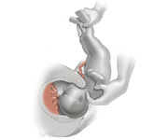
ALL THIS MANEUVERS HAVE BEEN DEMONSTRATED TO SHOW THE ASSISTED BREECH DELIVERY, WHICH STILL HAS PLACE IN MODERN OBSTETRICS AND SHOULD NOT BE TREATED AS A FORGOTTEN ART.

Mechanism of breech delivery
The most common position in breech left sacro anterior.
In breech delivery the mechanism takes place at 3 levels
- Delivery of breech
- Delivery of shoulder
- Delivery of after coming head
Delivery of breech:
a.Engagement : Said to have occurred when bitrochanteric diameter has passed through pelvic brim
b.Then decent of the breech with increasing compaction.
c.Internal rotation: As the breech reaches the resistance of the pelvic floor it rotates by 45 degrees and the bitrochantric diameter comes to anteroposterior diameter.
d.Lateral flexion: The anterior hip hinges under pubic symphysis, with increasing lateral flexion posterior hip born over the perineum, followed by delivery of the anterior hip ..
Delivery of the shoulder:
a.Engagement of shoulder ;Said to have occured when bisacromial diameter has passed through the pelvic brim.
b.Internal rotation: The shoulder rotates by 45 degree and comes to antero posterior diameter.
c.Birth by lateral flexion: The anterior shoulder hinges under pubic symphysis and posterior shoulder is delivered followed by anterior.
Delivery of the after coming head;
- Engagement of the suboccipito bregmatic diameter occurs in right oblique diameter.
- Decent with increasing flexion
- The occiput undergoes internal rotation and the suboccipito bregmatic diameter comes to anteroposterior diameter
- Birth by flexion.

